Ben Nachmanson

September 20, 2021

Project 2 Design Document

1. Requirements Document.
2. Overview

We will learn how to interface switch and LED components with our launchpad to build a simple traffic light. We will need to build circuits (using switches, LEDs, resistors) on the breadboard and connect them to the launchpad.

1. Function description

The stop light will remain green until a pedestrian sends a crossing signal. Green will turn off, then the next light will turn yellow. After some time yellow will turn off and the next light will turn red and if a car arrives the red light will turn off and the green light will turn on again. The delays between the lights are shown on “Diagram B” below.

1. Deliverables

This document will include a working stoplight on a launch pad with two switches that will have one switch being the pedestrian and another switch being the car arriving at the red light. Along with that there will be this report of course.

1. Design Document.

*Diagram A:*

*Diagram B:*

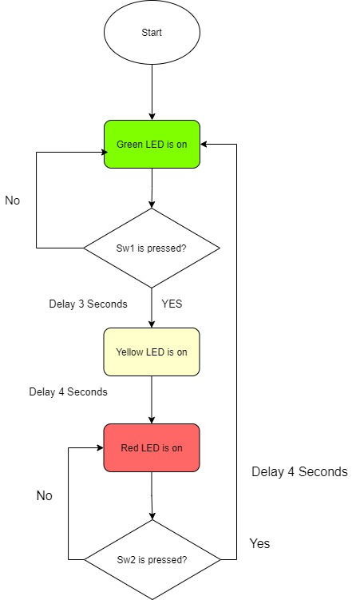

1. Discussions.

I implemented my delay using the method taught in Project 1. The value 145448 is used as .1 second and the value is looped accordingly I.e., 145448 \*10 = 1 second. I had a lot of difficulty with all the wiring and understanding the signal flow. Understanding how the LEDs would be powered and how the resistors would be all connected to the ground wire. Also, there was lots of difficulty with turning on different PE’s to be used as output or inputs within the code. If I were to improve this design, I would use motion sensors to more accurately measure where the vehicles are for better timing for the green light.